The Four Stroke Engine
The four-stroke engine is also called a four-stroke cycle engine.
This engine works on the principle of completion of four strokes of cycles of piston along the cylinder. Stroke refers to the complete travel of the piston along the cylinder in either direction. The four separate strokes are: Intake, Compression, Combustion and Exhaust strokes.
(a) Intake stroke;
During intake, the piston moves away from the cylinder and the combustion chamber. The intake valve opens. This creates low pressure within the cylinder and the combustion chamber which sucks in air and fuel, forming fuel-air mixture.
(b) Compression stroke;
With both the intake valve and the exhaust valve closed, the piston starts moving back towards the cylinder. The fuel-air mixture is subjected to low volume and high pressure due to compression by the piston.
At the smallest volume and highest pressure, the electrical contact is closed. Current flows through the spark plug.
(c) Combustion stroke;
This stage is also called power stroke.
Here, the piston is at its peak and the electrical contact has closed. Current flows through the spark plug while the electrical contact readily disconnects and opens. This sudden opening of the electrical contact results to generation of electrical sparks in the combustion chamber which in turn ignites the fuel-air mixture.
The ignition of the fuel mixture causes combustion. This results to production of heat and a sharp rise in the temperature of the combustion chamber. The whole process generates more pressure of the gases in the chamber, which pushes the piston away from the cylinder. The pressure exerted on the piston is transferred to the motion of the crankshaft which turns other cylinders or shafts connected to it.
(d) Exhaust stroke;
During exhaust stroke the piston moves to the far end leaving the exhaust valve open and the electrical contact open. The cylinder has low pressure. The cylinder and the combustion chamber are now full of exhaust gases and heat. The exhaust valve is open, allowing passage of exhaust gases out of the engine. This clears the cylinder in readiness for the next combustion cycle.

The following diagrams highlight the operation of the four stroke engine;
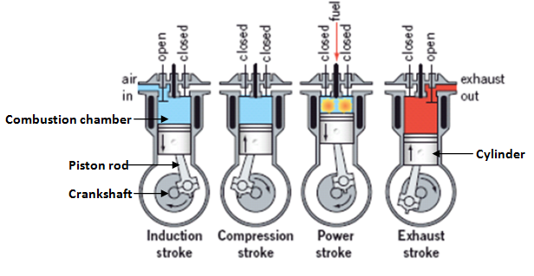
Figure 1.1

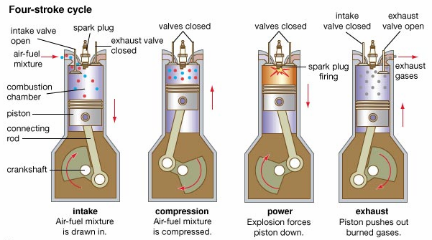
Figure 1.2

